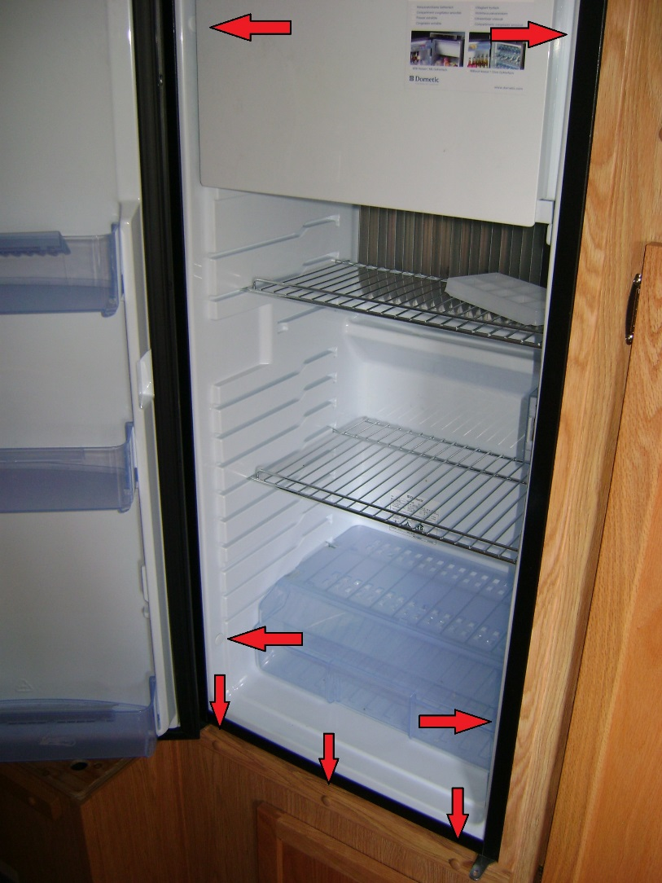
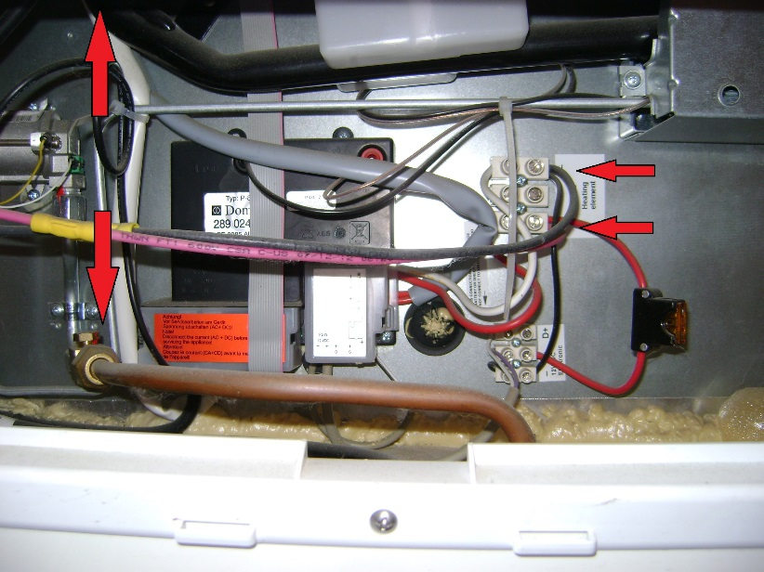

Removing the fridge for baffle install

Remove 4 white plugs on side of fridge and the 4 screws recessed in the fridge wall.
Remove the 3 brown snap caps on the trim below the fridge, and the screws.
You may need to remove the trim around the fridge.
Disconnect the battery

Remove the black and red 10 gauge wires
Disconnect the propane line. (Make sure to use 2 wrenches)
Unplug the 120V from the wall socket above and to the left.

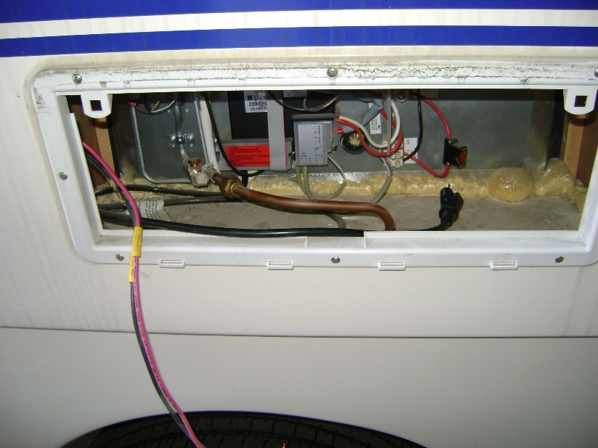

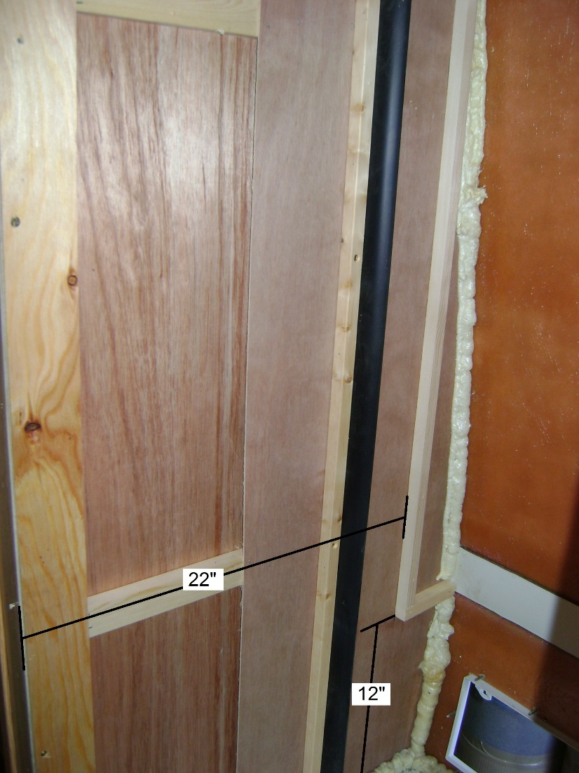

Cover the fridge line and propane line with tape

Mark 12” up from the fridge deck and 22” back from the front edge of the cabinet. Attach a 1x1 across the bottom (approx. 4.5”) and one from the top of the bottom block up (approx. 36”)

Watch for 120V wires. Use wood glue for the main bond of the blocks to the wall. Using brad nails or screws, anchor the lower blocks closest to each end of block. Stay away from the middle of the block. Attach the vertical block at the bottom end and at the top.

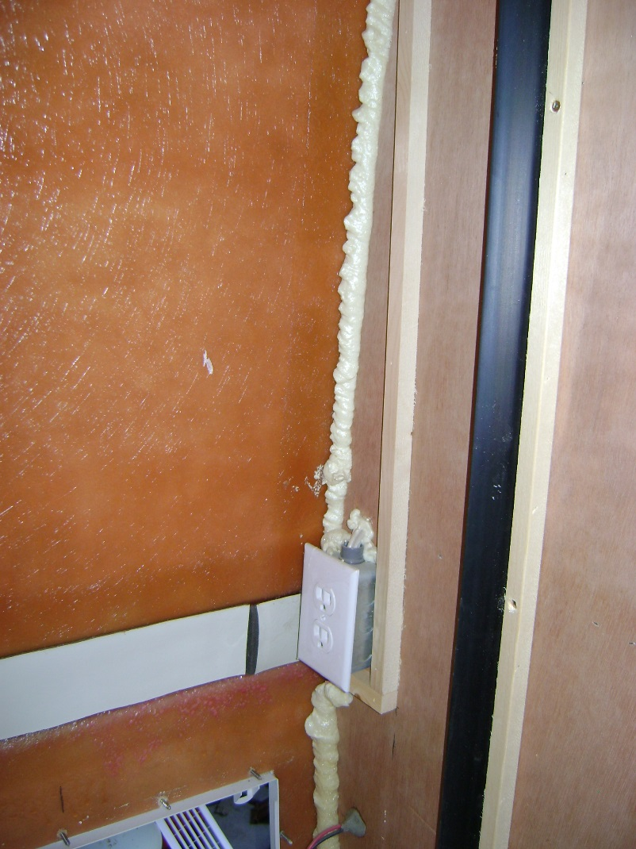
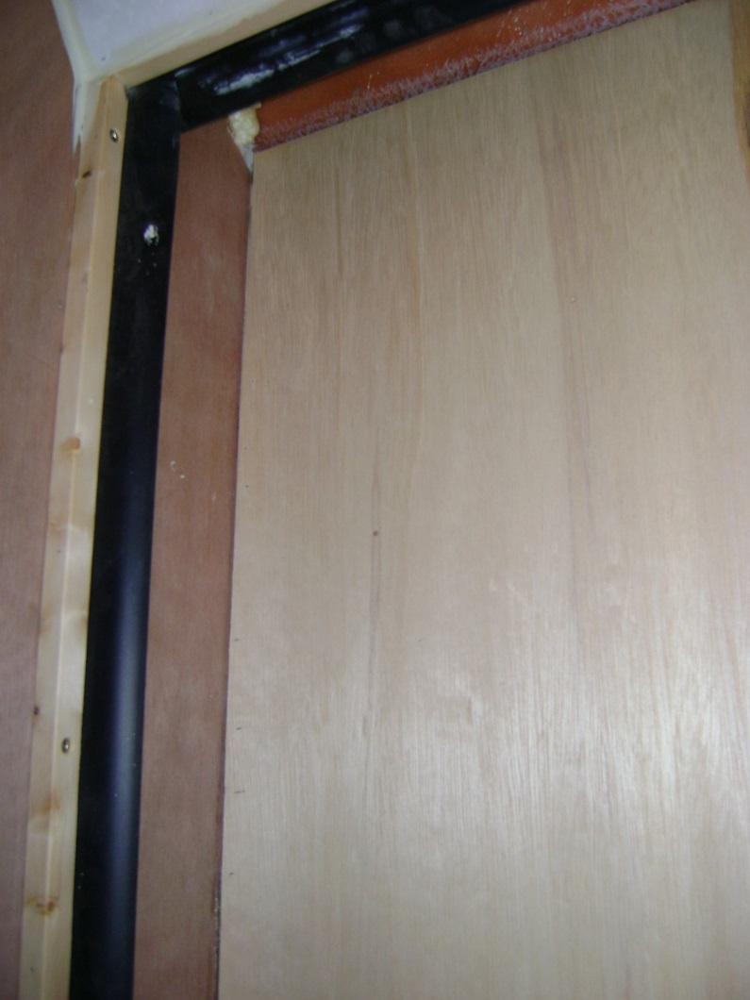

Install 1/8 panel with grain running vertically so it can flex into the cavity. Panel should be approximately 23” x 38”.

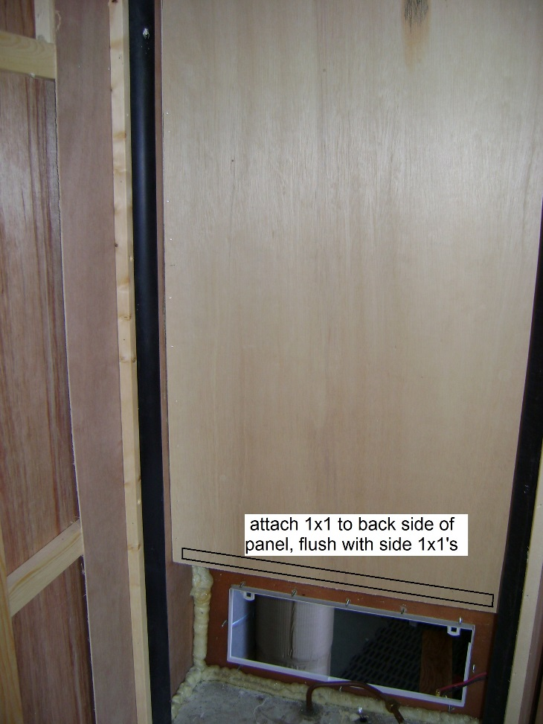

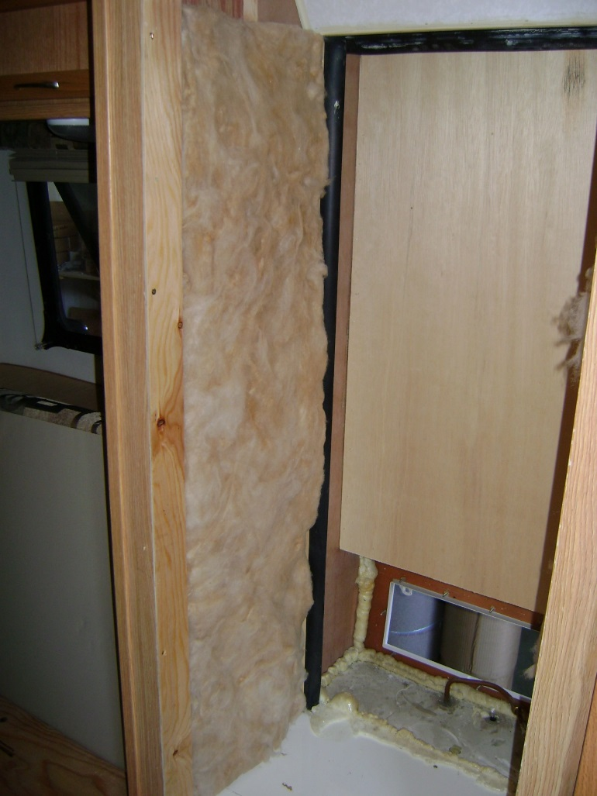

Attach a 1x1 on the lower back side of the panel flush with the side blocks. This is for attaching the lower cover plate.

Install approx. 1.5” thick insulation on the sides

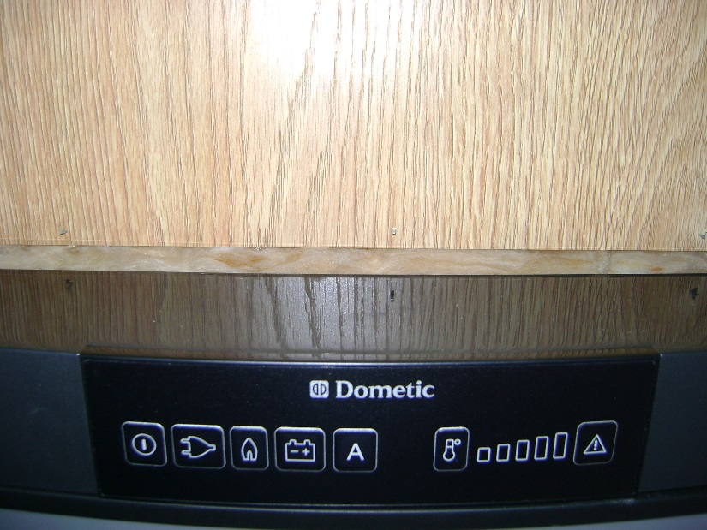
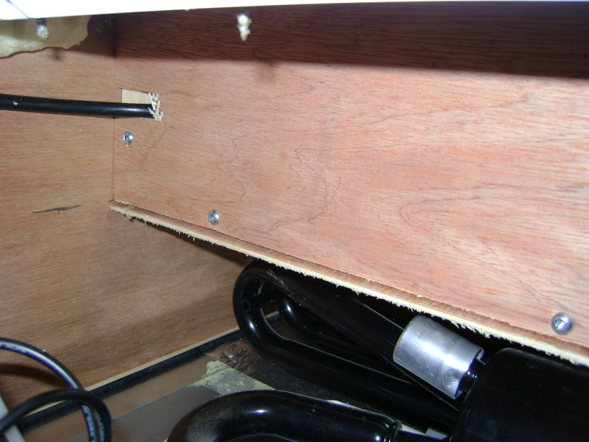

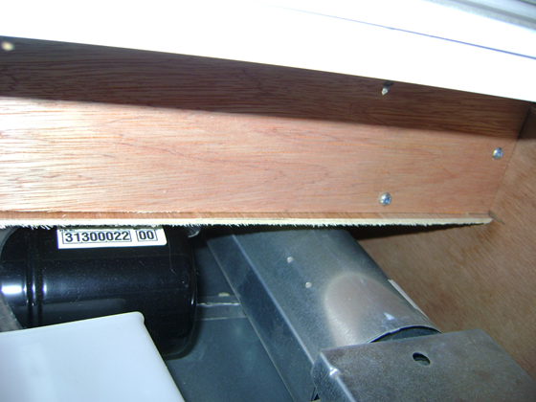

There is more room on the top of the fridge so 3” thick will fit.
Carefully slide fridge back into position, making sure the wires are free at the rear.

This picture is looking up at the bottom of the baffle.
Plug 120V cord into outlet, then install a piece of paneling approx. 23 x 4.5 and screw into place with screws.

Reconnect 12V and propane line. Test propane line for leak with soapy water.
Reinstall interior screws and trim.

